Nándor KEMÉNY
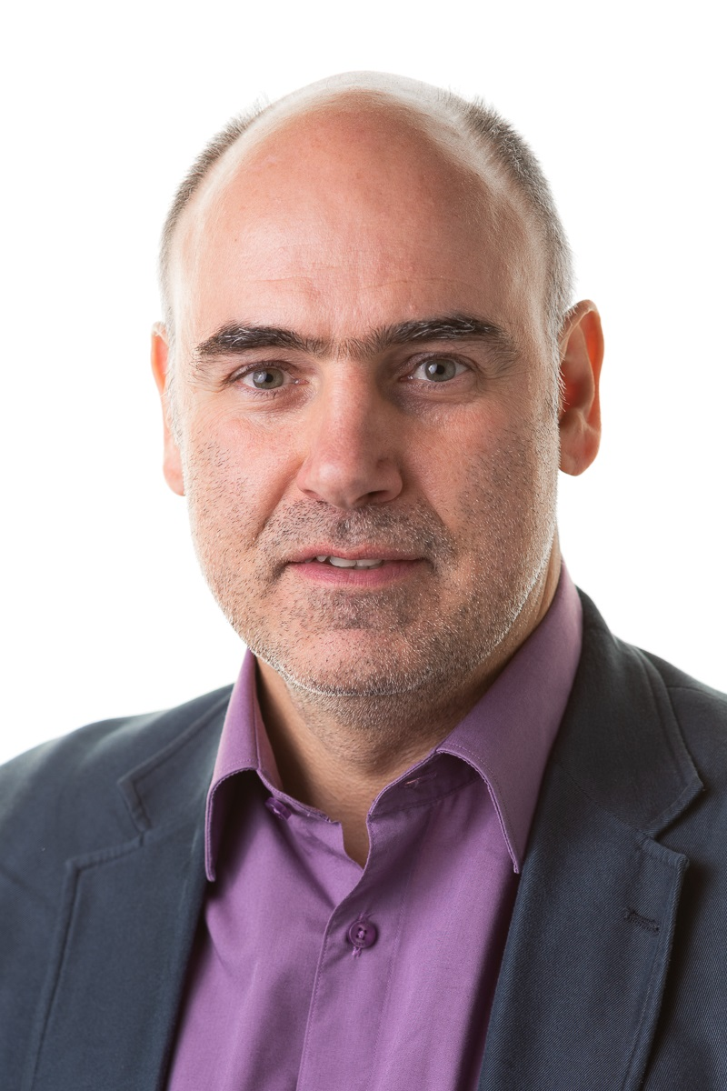
Mobile: +36 20 5506150
eMail: NK.cv@NandorKemeny.eu
LinkedIn: linkedin.com/in/nandorkemeny
Nationality: Hungarian
Born: 10th May 1966 in Budapest

Curriculum Vitae
2009 – Freelanced Lean-Agile Trainer, Coach and Developer Consultant

Roles/Experiences:
Delivering Trainings and Workshops (in English, in German and in Hungarian) on
- Agile Frameworks - Scrum and Kanban,
- Project Management Basics and PMP® Exam Prep,
- Agile Leadership and Agile Project Management,
- Agile Requirement Engineering, Release planning, Story Mapping,
- Lean for Agile Leaders and Organizations
Training and consulting for organizational development and introduction of Agile methods throughout the country at various organizations,
Coaching, Hosting of World Café meetings
Presenter on the AgiCon conferences and on Meetups
2017 - Agile Coach at evosoft Hungary Kft. (in Budapest, Hungary)

Roles/Experiences:
Coaching of Agile Teams, Scrum Masters, Product Owners and Agile Leaders
Introduction and application (training, customization, consultation) of Agile and Lean development methods (Scrum, Scrumban, Kanban, …, Portfolio Kanban)
Supporting huge international scaled projects with 10-35+ teams. Different scaling approaches from LeSS, SAFe or Spotify like unique frameworks
Leading of Agile and Lean transformations; delivering Trainings and Workshops on Agile methodologies
Facilitating of local and remote events for up to hundred participants

2017 Senior Consultant/Agile Coach at Sprint Consulting Llc. (in Budapest, Hungary)

Roles/Experiences:
Introduction and application (training, customisation, consultation) of Agile and Lean development methodologies (Scrum, Kanban, …)
Leading of Agile and Lean projects and transformations; delivering trainings and workshops on Agile methodologies

2016 – Agile Coach at Raiffeisen Bank Zrt. under contract with Pont Systems Zrt. (in Budapest, Hungary)

Roles/Experiences:
Support and coaching of a development team of 9-10 members and their Scrum Master; Delivering on-site Trainings
2015 – 2016 Senior Scrum Master/Agile Coach at K&H Bank Zrt. under contract with Pont Systems Zrt. (in Budapest, Hungary)

Roles/Experiences:
ScrumMaster of a delivery team, and shaping the Agile way of working at the Bank
Setup of the Agile metrics and reporting
2014 – 2015 Scrum Master at LogMeIn Kft. (in Budapest, Hungary)

Roles/Experiences:
Dedicated Scrum Master of two ongoing agile teams at the development of the Rescue product during the reorganisation of the company
2013 – 2014 CSM, PMP at Qualysoft Informatikai Zrt. (in Budapest, Hungary)

Roles/Experiences:
Start-up of two new agile teams as a Certified ScrumMaster, in an international project employing eight software-development teams
Product Owner at the development of a new R&D product
Project Manager at HP Enterprise Services ITO EMEA CDM
2013 IT consultant at AccepTher Kft. (in Budapest, Hungary)

Roles/Experiences:
Advice and assistance in the change of the IT architecture to a cloud based solution; development of the Web-appearance, Search Engine Optimization (SEO)
2011 – 2012 IT Architect at K&H Bank Zrt. under contract with S&M Projects Kft. (in Budapest, Hungary)

Roles/Experiences:
Advice and assistance in the relocation of the IT data centres, assuring the incident-free transition of the interfaces
2009 – 2011 Agile Project Manager at ApPello Kft. (in Budapest, Hungary)

Roles/Experiences:
Scrum Master; Introduction of agile project management methodologies. Training of colleagues in Project Management and several applications. Preparation for the ISO 9001 audit.

Projects:
Development of the KHR Central Credit-information System, development of the Teller-system, optimization of the Cash delivery, development of the Credit-qualifier System
2008 – 2009 Senior Project Manager at Protégé Consulting Kft. (in Budapest, Hungary)

Roles/Experiences:
Project management methodologically audit, consultancy and training at the IT subsidiary of a Hungarian bank
Project management at a Hungarian bank: MS Office upgrade, BCP system upgrade
2005 - 2008 Customer Support Manager at ORIMOS Financial Analytics GmbH (in Berlin, Germany)

Roles/Experiences:
Support of the customers of the SONARIS/Bonds Pricing System
Installation and configuration of existing and new systems, components and connections to external systems as Bloomberg, Reuters, Eurex
Training of fixed income traders and the technical staff
2001 - 2005 Teamleader and Senior Software Architect at Generali-Providencia Insurance (in Budapest, Hungary)

Roles/Experiences:
Leader of the Java programming team
Participation in design and organization of the Integrated Systems
Design of the Enterprise Application Integration (EAI) strategy
2001 Project manager at MKB Hungarian Foreign Trade Bank (in Budapest, Hungary)

Projects:
Digital Documents-Handling Pilot Project
Broker-Integration
1992 - 2000 IT-Consultant at Bankgesellschaft Berlin (in Berlin, Germany).

Roles:
Consulting, installation and production (administration, support) of office, networking and mainly banking IT systems and applications, in the largest Investment Banking Trading Room in Berlin.

Education:
1991 Graduation (Diploma) in Electrical Engineering at the University of Applied Sciences in Münster (Germany), Department Electrotechnics, Automation.
Special interests: Microprocessor technology, Expert systems
Thesis: Speech-pattern-recognition with the method of the dynamic programming
1988 Graduation (Diploma) in Electrical Engineering at the
“Kandó Kálmán” College of Engineering in Budapest (Hungary),
Departments Instrumentation and Automation,
Special field: Medical Technique.
Thesis: Software development for memory oscilloscope
1984 Vocational high-school Graduation at the “Bolyai János” Technical High-school of Communication Art, Budapest (Hungary).

Trainings:
2019 TPW8
2018 Certified Scrum Professional® ScrumMaster (CSP-SM) – ScrumAlliance
2016 TPW3
2015 Mediation Certification Training
TPW2
2014 Mediation Basic Training
TPW1
2013 Certified ScrumMaster® (CSM) – ScrumAlliance
Project Management Professional® (PMP) - PMI
2012 Coaching basic training
Gestalt & Organizational Development
2009 - Member and organizer of the Central Trainer Workshop for self-education
2009 How to become a developing leader, consultant? - Larsu Salonen
2008 Manager round-table – Organic view and development of enterprises
2004 Group leadership skills & techniques
2003 EQ – success in personal contacts
2001 Nonviolent (Assertive) Communication

Knowledge:

Professional:
Agile frameworks: Scrum, Kanban, Scrumban
Agile scaling frameworks (LeSS, SAFe, Scrum@Scale, “Spotify”,…)
Agile and Software development tools and applications
Different banking and insurance systems
PM methodologies: PMI PMBOK, IPMA, PRINCE2

Languages:
Hungarian (native)
German (proficient: C2)
English (proficient: C1)

Other:
Driving license (A, B)

Hobbies:
Travel, photography, reading, music, dancing, singing in choir

